## Problem 1 ##

> par(mfrow=c(3,1))

> time.code <- 1:600

> plot(time.code, veg.data[21329,4:603], type="l", main = "Plot of Site N21329", ylim = c(0,1000), xlab = "Readings from 1982 to 2006", ylab= " NDVI Score")

> plot(time.code, veg.data[21060,4:603], type="l", main = "Plot of Site N21060", ylim = c(0,1000), xlab = "Readings from 1982 to 2006", ylab= " NDVI Score")

> plot(time.code, veg.data[21151,4:603], type="l", main = "Plot of Site N21151", ylim = c(0,1000), xlab = "Readings from 1982 to 2006", ylab= " NDVI Score")

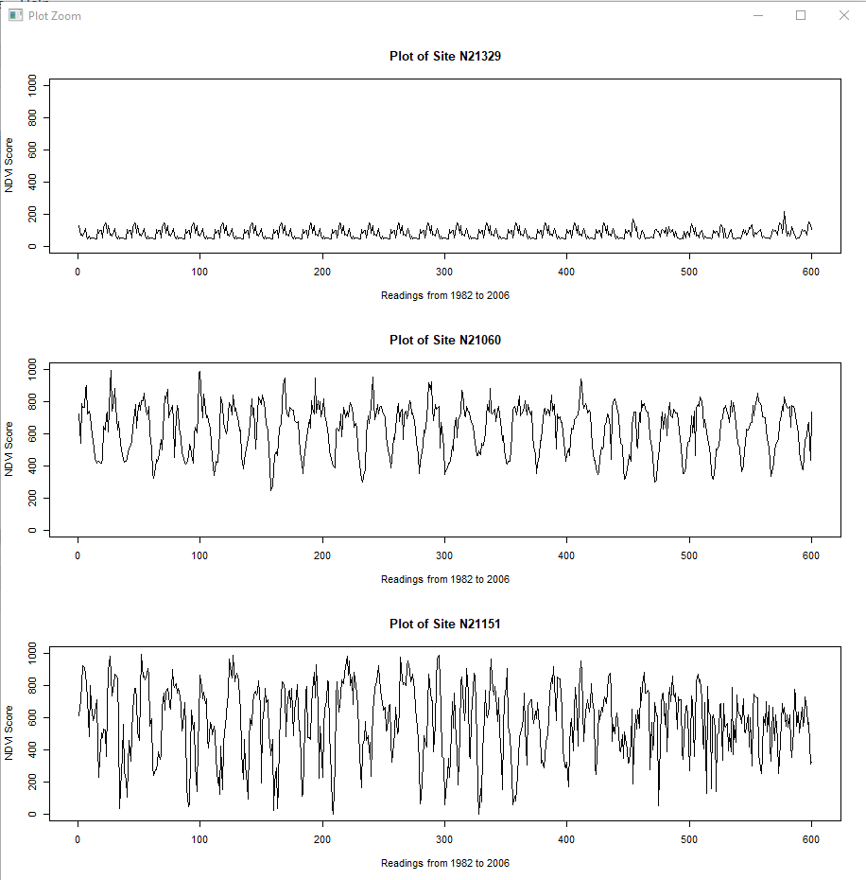

The first plot of site I selected to display (N21329) has very small NDVI values, in the 100-200 range. There is little variation, in comparison to the other two selected sites. Perhaps this site comes from a rocky or desert area with near to no vegetation over the period.

The second plot of site I selected (N21060) has a repitetive pattern according to the seasons. Having High vegetaion growth for summers (rainforest) and low vegetation growth in winters. The NDVI value spannig from 400-900 over 25 years periodically.

The third plot of site I selected (N21151) has a very irregular pattern. The NDVI values spaning from 100 to 900. Explaining that there is high water supply at some point in a year and also at times the water levels go down to make the region deserted.

## Problem 2 ##

> par(mfrow=c(1,1))

> plot(xcoord,ycoord, col="gray")

>

> for (i in 1:49681) {

+ if(avg.NDVI[i] <= 100) points(xcoord[i],ycoord[i], pch=20, cex= 0.6, col="brown")

+ if(avg.NDVI[i] > 100 & avg.NDVI[i] <= 300) points(xcoord[i],ycoord[i], pch=20, cex= 0.6, col="khaki1")

+ if(avg.NDVI[i] > 300 & avg.NDVI[i] <= 500) points(xcoord[i],ycoord[i], pch=20, cex= 0.6, col="lightgreen")

+ if(avg.NDVI[i] > 500 & avg.NDVI[i] <= 700) points(xcoord[i],ycoord[i], pch=20, cex= 0.6, col="green")

+ if(avg.NDVI[i] > 700) points(xcoord[i],ycoord[i], pch=20, cex= 0.6, col="darkgreen")

+ }

>

> legend(39.9,-5, bty= "n",c("NDVI <= 100","100 < NDVI <= 300", "300 < NDVI <= 500", "500 < NDVI <= 700","NDVI > 700" ),cex=0.6, fill =c("brown","khaki3","darkolivegreen1","green","darkgreen"))

